*Software Requirements Specification*

for >**Ride Me Application** <

>Prepared by> Team Soft 101

8-05-2024

**Scope**

Ride Me Application is software which It allows people to go wherever they want to go in a safe and comfortable way, at reasonable prices, and to choose according to their financial ability, and it allows them to express their opinion about the level of service.

**Architecture Patterns: Layered Architecture**

|  |
| --- |
| **The presentation layer** : it have the user interface for user, admin and driver |
| **The business logic layer and Data access layer** : It contains function of each user in the system and handling function |
| **The database layer** : This is where all the data is stored. |

**Benefits of layered Architecture in the system:**

* Layers make reuse easier, dependencies between layers are minimized. A layer can easily be changed with a different implementation without a system destroy development and evolution can make easy and testing each component becomes more easy. It also increase reliability and availability
* ***Description***

Ride Me is an application based on transportation platform that connects riders with drivers. Users can request a ride through the app, specifying their pick-up and drop-off locations. The app then locates available drivers nearby and displays estimated fares and arrival times. Once a rider chooses a driver, they can track their location in real-time on a map.

***System Requirement Specification***

**Functional Requirements**

**login**

|  |  |
| --- | --- |
| **1.login** | The admin must allow the user Sign in the application |
| **2.login** | The admin must allow the user change the password |
| **3.login** | The admin must allow the user log out from application |
| **4.Login** | The admin must allow the user delete account from application |

**driver**

|  |  |
| --- | --- |
| **1.add** | The admin can add driver |
| **2.remove** | The admin can remove driver |

**ride**

|  |  |
| --- | --- |
| **1.ride** | The admin must allow the user to **order ride** |
| **2.ride** | The admin must allow the user to **cancel ride** |
| **3.ride** | The Driver can accept ride |
| **4.ride** | The Driver can Reject ride |

**Search**

|  |  |
| --- | --- |
| **1.Search** | User can search for nearby drivers |
|  |  |

**Feedback**

|  |  |
| --- | --- |
| **1.Feedback** | The admin must allow for user to sent a feedback about services |

**3.2 Non-Functional Requirements**

* ***LOOK AND FEEL REQUIREMENTS***

* This system is user friendly.
* Approachable, so that people do not hesitate to use it.
* Authoritative, so that users feel they can rely on it and trust it.
* Attractive to students or some other specific group.
* Innovative and appearing to be state of the art.
* Cool.

**Performance**

|  |  |  |
| --- | --- | --- |
| **1.** **Performance** |  | The application must respond the business operation in less than 3 seconds for user |
| **2.** **Performance** |  | The application should be reliable. |
| **3. Performance** |  | The application must mange many users at the same time |

**Simple**

|  |  |
| --- | --- |
| **1. Simple** | Shall at maximum three color |
| **2. Simple** | Decrease confusion. |
| **3. Simple** | The product be easy to use on the first attempt by a member of the faculty without training |

**flexible and maintainable**

|  |  |
| --- | --- |
| **1.FM** | The product shall be used on both computer and cellphones |
| **2.FM** | The product be able to be modified to cope with new courses, subjects, staff, and departments. |

**safe and secure**

|  |  |
| --- | --- |
| **1.SS** | The product shall ensure that only authorized admins can manipulate information. |
| **2.SS** | The product shall be immune against threats and attacks |

**formal**

|  |  |
| --- | --- |
| **1.Formal** | The product shall comply with the college laws. |
| **2.Formal** | The product shall comply with the laws of the ministry of higher education in Egypt |

**Usability and Humanity**

|  |  |
| --- | --- |
| **1.UAH** | Centralized maintain all information. |
| **2.UAH** | Easy to search for good drivers |
| **3.UAH** | The system will save significant amount of time and effort. |
|  | Easy to manage whole counseling procedure. |
| **5.UAH** | Facilitate communication between Admin and User. |
| **6.UAH** | Easy to use on the first attempt by someone without training. |

**Operational & Environmental REQS**

|  |  |
| --- | --- |
| **1.OAE** | website shall conserve data of .internet . |

**Look-and-Feel REQS**

|  |  |
| --- | --- |
| **1.Look and Feel** | website should be beautiful .. The colors are consistent.. |

**Reliability**

|  |  |
| --- | --- |
| **1. Reliability** | The system servers and services should be available when it is requested by the user. |
| **2. Reliability** | user can easily connect with admin or system is any problem happened. |
| **3. Reliability** | has a very high-quality maintaining system to avoid any crash. |

**OCL(object constrains language):**

context User

inv :name: not null

inv : email: unique, not null

pre :password: not null, at least 5 characters

inv :phone: unique, 11 num long

context Driver

inv:name: not null

inv: phone: unique, 11 num long

post : rate: between 0:10

context Ride

post : Rate: between 0:10

Context Admin

Inv :Name: not null

**Class diagram**

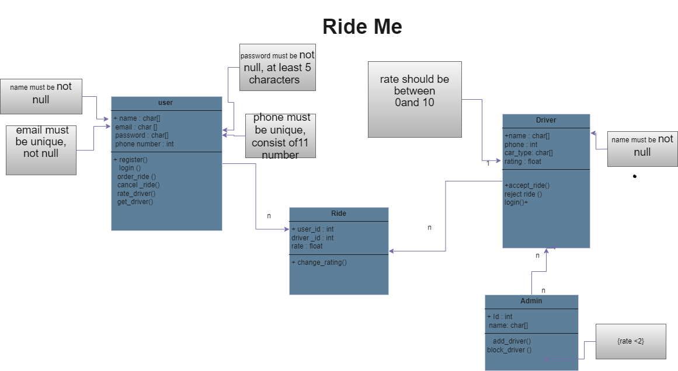

**Sequence diagram**

صورة تحتوي على لقطة شاشة, نص, رسم بياني, خط

تم إنشاء الوصف تلقائياً

**Use Case diagram**

**صورة تحتوي على نص, لقطة شاشة, رسم بياني, خط

تم إنشاء الوصف تلقائياً**

**Activity diagram**

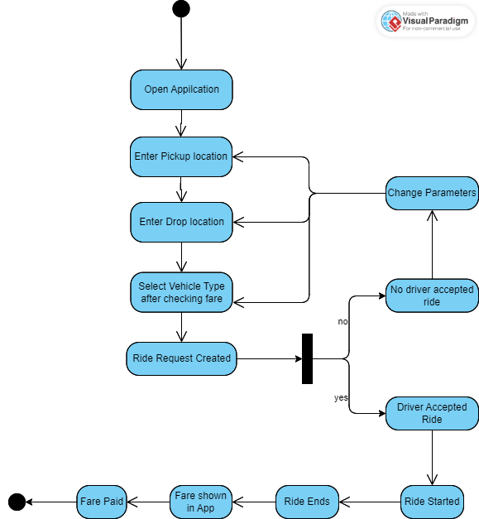

ERD

صورة تحتوي على نص, رسم بياني, خطة, رسم تقني

تم إنشاء الوصف تلقائياً